Here follow nine more chart examples bringing the total to twenty-one for long-record rural sites. For brevity and avoidance of repetition, the accompanying textual information is progressively reduced but can be tracked down if desired via links in References.

Fig 13) Yamba:
- Another case of there being no data in CDO prior to 1957 despite that ACORN is believed to be based on that missing data. (Possibly a case of institutional haste to get their message out without due diligence or proper methodology? Please pardon my pure speculation.)
- It is also questionable why it is that ACORN and CDO are common for a mere seven years in this particular case, whereas other stations have extremely erratic commonality for up to 104 years. I opine that this question has serious implications and that it ought to be appropriately addressed by authority!
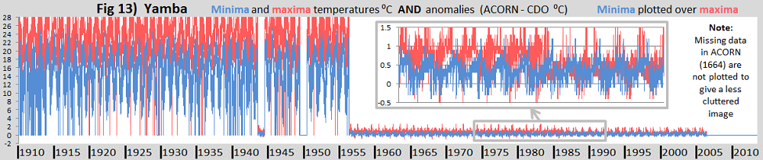

Fig 14) Wilsons Promontory:
- Another case of no CDO data to the left hand side.
- To add some colour to the otherwise uninteresting right hand side, the distribution of missing ACORN data (1927 & 715 days resp.) is shown. It is of comparative relevance to the observation made at Fig 20) on some Automatic Weather Station (AWS) concerns.
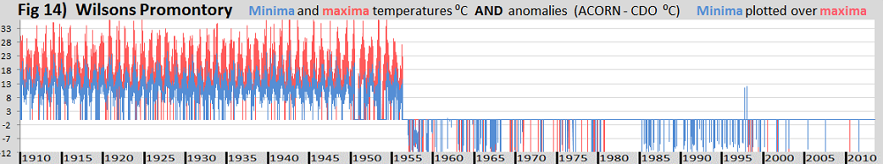

Fig 15) Katanning:
- It seems illogical that the minima should have a single uniform step-change lasting some 75 years.
- In contrast the maxima have five step-changes
- The maxima also have some pronounced variability in seasonal cycles, most strongly and unaccountably from 1910 to ~1926.
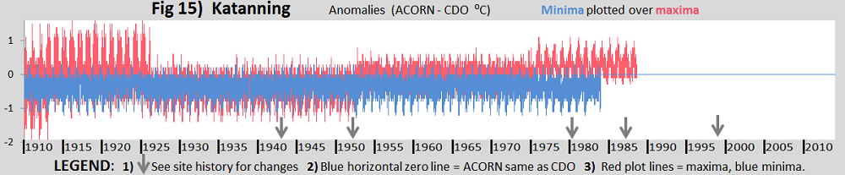HISTORY from the ACORN catalogue: There are documented site moves in July 1987 (100 m north), January 1952 (200 m) and December 1942 (10 m north). A new screen was installed on 11 February 1980.

Fig 16) Moruya Heads:
- Another one missing the essential CDO data before 1/Jan/1957.
- ACORN is the same as CDO in the minima back to about 1956, (some ten years less in the maxima).
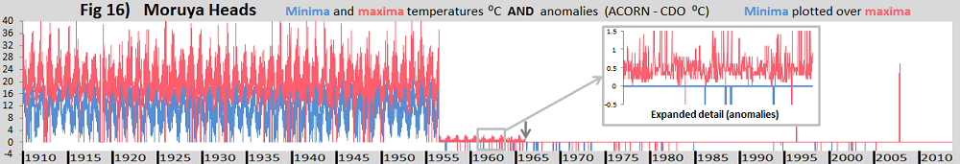

Fig 17) Gabo Island:
- Another one with no CDO data before 1/Jan/1957, which ACORN requires in order to make its prognostications back to 1910.
- Prior to about 1972 the seasonality is very flat but then becomes quite pronounced (but only in the maxima before anomalies are eradicated by CDO being made common with ACORN!)
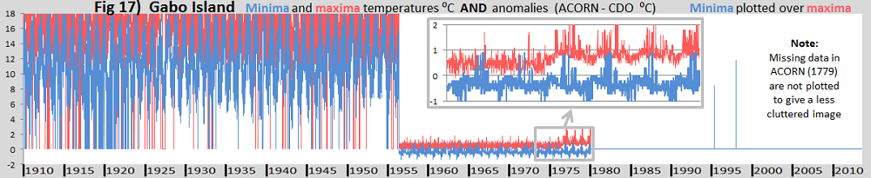

Fig 18) Bundaberg:
- And now for something a little different: The distribution of missing ACORN data is indicated in this figure by values ranging off-chart beyond +/-2⁰C. This reveals one of the common effects of introduction of an automatic weather station (AWS)
- Apart from with the AWS introduction, the other documented changes do not disturb the general uniformities prevailing beforehand, (although there are rather poor record incompleteness patches in the 1920’s and rather so in the 1960 early 70’s)
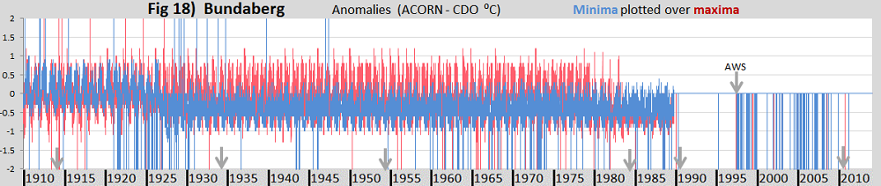HISTORY from the ACORN catalogue: The original site (039015) was located at the Post Office in the centre of town. A new screen was installed in June 1913. There was a small move into a new screen in June 1933, and a move of 50 m in July 1953. The site was enclosed, particularly in its later years, and there were bitumen surfaces in the vicinity from 1984 onwards. Observations began at the airport (039128) in July 1990. An automatic weather station was installed on 19 December 1997. The site moved on 1 July 2010 from the northern to the southern part of the airport, about 2 km south.

Fig 19) Bathurst:
- The expanded detail view reveals much ACORN data missing (to zero) in the maxima, whilst minima are good.
- Sharp step changes and seasonal profiles are not explained in the site history.
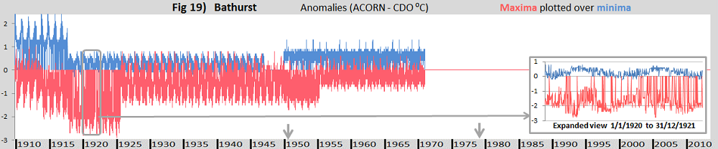HISTORY from the ACORN catalogue: Prior to December 1971 the screen did not strictly meet specifications, having single rather than double louvred sides. The site moved 800 m in an unknown direction in July 1950, and 30 m east in November 1978. On 16 April 1996 the site moved 200 m. Parallel observations continued at the old site for two years…

Fig 20) Bourke:
- Apart from some wild extremes in BoM corrections in the minima, everything was going relatively smoothly since the ‘1910 beginning of time according to the BoM’s ACORN standard’ through to 1995. Then it all fell apart with the move from the Post Office to near the airport terminal and then a substantial move away from the terminal and introduction of an Automatic Weather Station (AWS).
- Some of the problems in recent decades including with AWS’ are a study in progress. (Compare Fig 18)
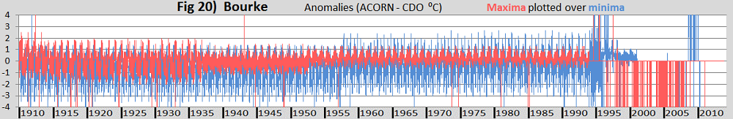HISTORY from the ACORN site catalogue:
Observations were originally made within the Bourke township (048013). This site had trees and buildings nearby and the lawn around the screen was regularly watered. There was a small site move within the Post Office yard in May 1937, and the screen was replaced in November 1964. A site (048239) was established on the southern side of the airport near the terminal building on 11 November 1994. Observations continued there until January 1999. The current site began operations in December 1998, 700 m north of the previous airport location but with only a minimal overlap. These data are used in ACORN-SAT from 1 January 1999.

Fig 21) Boulia: Inadequately explained step changes found from the site history
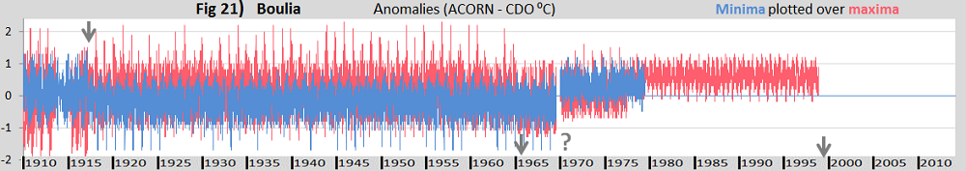HISTORY from the ACORN site catalogue: The site was originally in the town centre. A damaged screen was replaced in March 1917; there were periods of suspect maximum temperature data in the lead-up to this. Small moves took place in September 1965 and June 1970 (unconfirmed). The town site had a well-watered lawn surface, at least in its later years. The site moved to its current location at the airport in July 1999.

Compiled by Bob Fernley-Jones 11/Aug/2015 (slight rev. /Sep/2015

