Here follow six more chart examples. For the sake of brevity and avoidance of repetition, the accompanying textual information is progressively reduced but can be tracked down if desired via links in References.

Fig 7) Richmond P.O. Queensland:
- There are some fourteen step-changes (ACORN – CDO) which are mostly anomalous and unconnected with documented site changes
- The range of extremes in the maxima is excessive prior to 1950, maybe related to history of; [in 1944 the screen] “was reported to have had an iron roof”? (despite the insistence on proper Stevenson screens!)
- Prior to ~1972 the minima and maxima step-changes are broadly in step but subsequently they sharply diverge by >1⁰C without explanation.
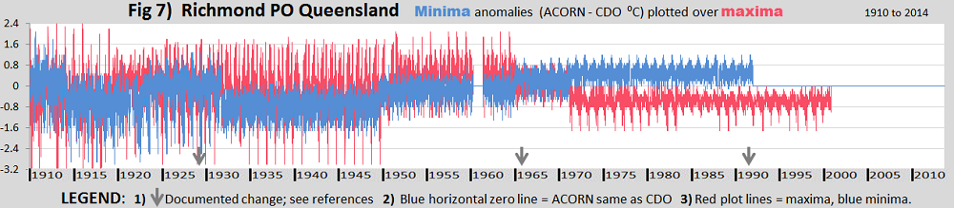HISTORY from the ACORN site catalogue: The only known station move was one of 30 m in September 1965. New screens were known to have been supplied in December 1928 and September 1991; the screen in use in September 1944 was reported to have had an iron roof.

Fig 8) Rutherglen:
- The three blocks of red are corrupted data caused by CDO records being transcribed one day out of phase with ACORN
- The bizarre underlying monthly cycle of the daily data is again revealed
- See Figures 2, 3 and 4 for additional related information
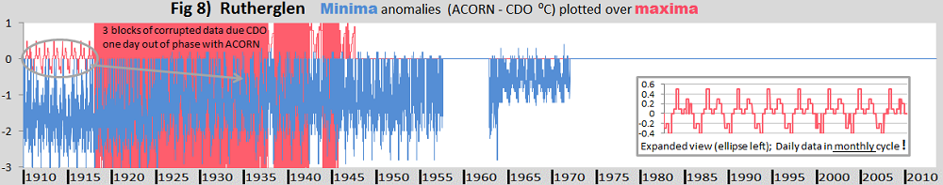HISTORY from the ACORN site Catalogue: There have been no documented site moves during the site’s history. The automatic weather station began operations on 29 January 1998.`

Fig 9) Cape Otway:
- Uniform “correction” in the minima for some 78 years is inexplicable
- The seasonality profile in the maxima within the first decade together with its atypical divergence has no explanation and it is also rather similar in the 1990’s
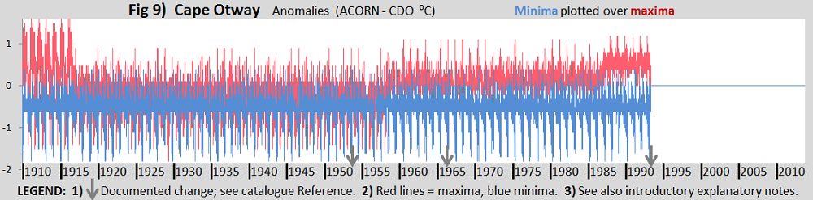HISTORY from the ACORN site Catalogue: This site has been in the grounds of the Cape Otway lighthouse throughout its history. The screen was reported as being in poor condition, and replaced, in July 1954. There was a small site move in September 1966. The first automatic weather station was installed on 15 April 1994, but this proved unreliable and it was replaced in March 1995.

Fig 10) Robe:
- This is an extreme example of CDO data being the same as ACORN for long periods in variety without any apparent reason. (See also fig’s 1 and 4).
- Step-changes apparently based on vague site details including “There were issues with the screen door for some years prior to repairs in 1930” (yet somehow they determined a decadal “correction”!).
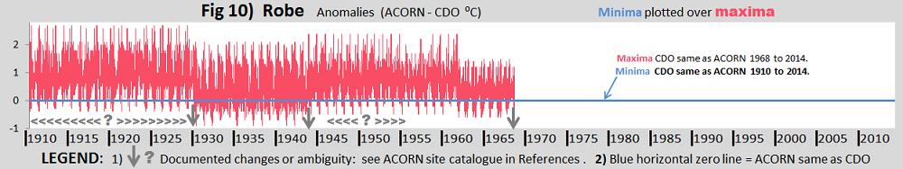HISTORY from the ACORN site Catalogue: There were issues with the screen door for some years prior to repairs in 1930. There was a very small move (3 m) in October 1943, and documentation also suggests a small move at some point in the decade prior to 1956 but there is no clear evidence of its nature or timing. There was a move 200 m east in November 1968

Fig 11) Palmerville
- Similar to Fig 5, there are no CDO data before ~1957, despite that the ACORN data are thought to be based on that missing data
- The solid blocks of colour 1910 to 1913 are found to be caused when expanded in finer view by there being much data also missing in ACORN
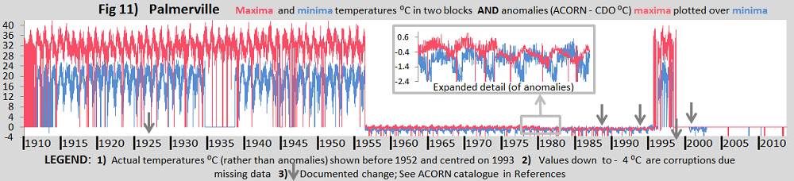HISTORY from the ACORN site Catalogue: There are no clearly documented moves at the original manual site although the screen was replaced on a number of occasions (October 1926, July 1988 and September 1994). The same observer performed observations for 63 years from 1936 to 1999, and was the area’s sole remaining resident during the later part of that period. Observations did not resume until the automatic station was commissioned. The automatic weather station was installed in mid-2000, 160 m south‑east of the former site, but did not begin transmitting data until July 2001.

Fig 12) Alice Springs
- Twelve slight to modest step-changes in the minima anomalies show little correlation with documented site changes.
- Excessive extremes in anomalies between 1910 and ~1947 ranging from about +6 ⁰C to -6⁰C, mostly in the minima.
- The annual cycles show sharp seasonally different profiles in four periods with no apparent justification.
- These issues are most extreme prior to the move to the airport, which presumably became a more exposed position, (suggesting relatively unreliable data in-town).
- Inexplicably CDO and ACORN maxima anomalies are the same for a much longer than in the minima and in two periods.
Three different stations have been merged. They do not appear to meet “World’s Best Practice”.
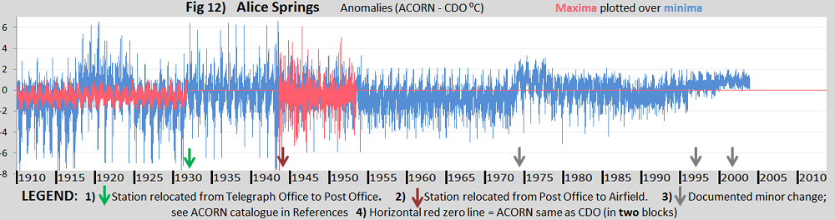HISTORY from the ACORN site Catalogue: The original site (015540) was at the Telegraph Station, 3 km north of the town. There is no known documentation of the screen type at the Telegraph Station but the observations are consistent with a Stevenson screen having been used there. The site was enclosed by a rock wall about 1 m high and painted white that would have interrupted wind flow and reflected heat. Observations moved to the Post Office on 23 January 1932. The Post Office site continued until 1953 but data after 1944 were not used in ACORN-SAT as there appear to have been changes at the Post Office site around the time that the airport site opened. Measurements have been taken at the airport (015590) since 1941. There was a site move (550 m east-northeast) in July 1974. An automatic weather station was installed on 21 March 1991 and became the primary instrument on 1 November 1996. The site moved a few metres west on 27 May 2002.

Compiled by Bob Fernley-Jones 11/Aug/2015 (rev. /Sep/2015)``

